MEMORANDUM
Centre for Laboratory Medicine and Molecular Pathology (LabMed Directorate)
St. James’s hospital, James’s Street, Dublin 8
Telephone 01 416 2919 Email: labmedsec@stjames.ie

From: Fiona Kearney, Laboratory Manager
Dr. Niamh Leonard, Clinical Lead for Mortuary services
To: Mortuary users
Subject: Information on Mortuary removals
Date: 01/11/2022

Dear Colleagues,
Mortuary Removals are currently restricted in SJH as follows:
Removal times are from 8am to 4pm daily Monday to Friday.
Removals outside of routine hours and especially at weekends must be agreed in advance with the Head of Chaplaincy and Pastoral services and Mortuary personnel, and will proceed only under exceptional circumstances.
The maximum number of visitors attending Mortuary Removals is restricted to prevent overcrowding in the Chapel.
FFP2 Face masks are encouraged to be worn by visitors attending the Mortuary.
We thank you for your co-operation.

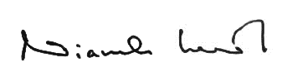
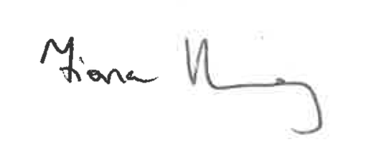
Kind Regards,

_________________________ ____________________________
Fiona Kearney, MSc MBS FACSLM Niamh Leonard, MCRN 15431
Laboratory Manager Clinical Lead for Mortuary Services

